Multi-century ice dynamics of Lake Suwa and River Tornio: Climate change, large-scale climate drivers, and air temperatures

Abstract

Lake ice is a sensitive indicator of climate change and variability. Climate change, large-scale climate drivers, and weather are all important drivers of ice freeze and breakup dates for Lake Suwa, Japan from 1443-2004 and Tornio River, Finland from 1693-2013. Using long-term records, we identify a regime shift in ice freeze and breakup coinciding with the start of the Industrial Revolution, the end of the Little Ice Age, and increases in atmospheric CO₂ concentrations and air temperatures. In the past century relative to earlier centuries, we observed earlier ice breakup, later ice freeze, a doubling to tripling in the rates of change in the timing of ice freeze and breakup, decreased importance of very short-term or long-term oscillatory dynamics for River Tornio, and increased probability of no-freeze years in Lake Suwa. Using these long-term ice records we highlight the fallacy of using short-term records to infer progressive climate change or the absence of it when so much variation in ice dynamics is caused by inter-annual and decadal climate drivers and local weather.

Introduction

Lake ice is a sensitive indicator of climate change. Northern Hemisphere lakes have shifted towards later freezing, earlier breakup, and shorter ice cover over the past 150 years (Kuusisto 1987; Robertson et al. 1992; Magnuson et al. 2000; Weyhenmeyer et al. 2011; Benson et al. 2012; Sharma et al. 2013). We analyze the longest known contemporary ice records dating back to 1443 for Lake Suwa, Japan and 1692 for River Tornio, Finland. These two time series encompass major events including the Little Ice Age, a 13 fold increase in human population size (United Nations Department of Economic and Social Affairs), the industrial revolution, substantial land use change, and increases in air temperature (IPCC 2013). Annually resolved contemporary ecological data spanning centuries are rare; however, Shinto priests recorded ice freeze dates in Lake Suwa since 1442 because they believed that the pressure ridges in the ice were formed as a result of God crossing the lake to visit the goddess (omiwatari in Japanese; Arakawa 1954; Mikami 2008). Ice breakup dates have been recorded from the River Tornio since 1692 because the river has been important in trade, transportation, food, and recreation (Loader et al. 2011).
Climate change, large-scale climate drivers, and local weather are interacting factors contributing to ice phenology. Climate change is contributing to earlier breakup, later freeze, and shorter ice cover duration for lakes and rivers around the Northern Hemisphere (Magnuson et al. 2000; Weyhenmeyer et al. 2011; Benson et al. 2012; Sharma et al. 2013). Large-scale climate drivers that have been found to be associated with lake ice breakup dates in the Northern Hemisphere, include the Quasi-Biennial Oscillation (QBO), El Niño Southern Oscillation (ENSO), Solar Sunspot Cycle, Pacific Decadal Oscillation (PDO), and North Atlantic Oscillation (NAO). In previous studies of lake ice dynamics, the positive phases of ENSO, NAO, and solar sunspots corresponded to later ice breakup dates (Livingstone 2000; Robertson et al. 2000; Magnuson et al. 2004; Bonsal et al. 2006; Ghanbari et al. 2009; Bai et al. 2012; Benson et al. 2012; Mudelsee 2012; Sharma et al. 2013). Local weather also contributes to ice phenology. For example, air temperature, snowfall, snow depth, wind events, cloud cover, and solar radiation can affect the timing of ice breakup and freeze dates Palecki and Barry 1986; Vavrus et al. 1996; Lepparanta and Wang 2008; Ghanbari et al. 2009; Jakkila et al. 2009; Benson et al. 2012).
Our overall objective is to characterize the variation in ice dynamics and identify drivers contributing to changes in variation at annual, decadal, and centennial scales for Lake Suwa, Japan, and River Tornio, Finland. More specifically, our research questions are: i) What are the patterns of ice freeze in Lake Suwa and ice breakup in River Tornio?; ii) Is there evidence for a regime shift in the time series?; iii) Have the same oscillatory dynamics persisted through the time series?; and iv) What is the relative importance of the various drivers (climate change, atmospheric conditions, large-scale climate drivers, and local weather) on freeze and breakup dates?

Methods

Data Acquisition

Ice freeze and breakup dates

We obtained ice freeze dates for a 550-year period from 1443-2004 for Lake Suwa and a 321-year record of river ice breakup dates for River Tornio from 1692-2013 from the National Snow and Ice Data Center (NSIDC; Benson and Magnuson 2000). Lake Suwa is a relatively shallow lake (Zmax = 7.2 m) in Nagano Prefecture, Japan where ice-freeze dates have been recorded since 1443. Ice freeze dates occur before and after January 1st, therefore we converted dates to Day-Of-Year (DOY) where a zero value represents the calendar day January 1st. If the lake did not freeze, we used the latest observed ice freeze date for that lake (Benson et al. 2012). Data gaps (e.g., 1682-1736; 1872-1896) were excluded from the time series analyses. Ice breakup dates from River Tornio have been recorded since 1693 and converted to Julian day including considerations for leap years.

Large-scale climate drivers and weather

We obtained data from paleo- and historical records that may be important to ice freeze date on Lake Suwa and ice breakup date on River Tornio (Table S1). We acquired average annual sunspot number from 1700-2012 which represents a relative index of solar activity for the visible solar surface from the Solar Influences Data Analysis Center (SIDC-team 2013), volcanic aerosols measured as the annual global average aerosol optical depth inferred at 550 nm from 800-2000 AD derived from sulphate measured in ice cores from Antarctica and Greenland from National Oceanographic and Atmospheric Association (NOAA; Crowley and Unterman 2013), solar irradiance from 9400 BC – 1988 AD acquired from radionuclides extracted from ice cores and tree rings used as a proxy of nuclear reactions with solar activity within the Earth’s atmosphere (Steinhilber et al. 2012), and atmospheric carbon dioxide concentrations from 1AD -2012 AD from contemporary atmospheric concentrations from Mauno Loa, Hawaii and splined CO₂ records derived from Antarctic ice cores (Keeling et al. 2001). We also acquired an index of El Nino Southern Oscillation (ENSO) from 1301-2005 derived from the North American Drought Atlas (Li et al. 2011) and winter (December-March) North Atlantic Oscillation index from 1659-2013 (Luterbacher et al. 2002; Hurrell et al. 2013).
We acquired local and regional air temperatures for both locations. For the Lake Suwa analysis, we included reconstructed growing season temperatures from Hokkaido, Japan derived from tree ring analysis from 1557-2007 (Davi et al. 2001) and local temperatures from Tokyo weather station from 1879-2013 (JMA 2013). For River Tornio, we acquired reconstructed records of monthly temperature adjusted to Haparanda, Sweden from 1802-2002 (nearby town to Tornio; Klingbjer and Moberg 2003). These were updated with monthly records from the Haparanda weather station for 2003-2013 from the International Surface Temperature Initiative (Thorne et al. 2011). Reconstructed monthly and annual temperatures for central Europe were obtained for the time series between 1500 and 2007 (Dobrovolný et al. 2010). Finally, reconstructed growing season temperatures derived from tree ring analysis from central Sweden were acquired from 1107-2007 (Gunnarson et al. 2011; Supplementary Table S1).

Data Analysis

Patterns of ice freeze in Lake Suwa and ice breakup in River Tornio

To investigate long-term trends in the timing of ice freeze on Lake Suwa and timing of ice breakup on River Tornio, ice freeze and breakup dates were fit using linear, second-order polynomial, and exponential regression models. We selected the best fit model by examining model fit and invoking the principle of Occam’s razor (where parsimony is always favoured). Statistical analysis was conducted using R Software for Statistical computing and the lm, nls, and step functions (R Software 2013).

Is there evidence for a regime shift?

A Bayesian approach was used to identify a breakpoint for ice freeze and breakup dates. We used uninformative priors for two different means (or periods) and utilize the beta distribution to determine the breakpoint (McCarty 2007). We assumed that the standard deviations for both periods are the same and, in fact, subsequent F-test, Bartlett and Levene tests confirm that that there is no significant difference in variance between periods. Three Markov chains with 10,000 iterations were used in the analysis to determine the breakpoint for each time-series. The analysis was conducted using the rjags library in R software (Plummer & Stukalov 2013).

Have the same oscillatory dynamics persisted through the time series?

Continuous Wavelet Transform (CWT) was used to determine what cycle lengths contribute to ice breakup date on the River Tornio (Torrence & Compo 1998; Percival & Walden 2000). CWT analysis was only applied to the River Tornio time-series because this series has no missing values, unlike the Lake Suwa ice record (Torrence & Compo 1998; Percival & Walden 2000). CWT attributes variance to cycle lengths by conducting several passes of the morlet wavelet template at different sizes over the entire time-series (James et al. 2010; Percival & Walden 2000). The degree of similarity between the time series and the morlet wavelet template at each template size and each position is assessed through wavelet coefficients (James et al. 2010). If the fit between data and template is good, a high value for a wavelet coefficient is given, however, if the fit is poor the wavelet coefficient will be close to zero (Dale and Mah 1998). We implement CWT in R using the biwavelet package (Gouhier & Grinsted 2013).
More specifically, we first detrended the time-series and implemented CWT on the residuals using a morlet wavelet template, a common template used for dendrochronology and other climate sensitive analyses (e.g. Keener et al. 2010, Rouyer et al. 2008). A bias towards large-scale cycles was corrected by using a procedure developed by Lui et al. (2007) to calculate wavelet variance. The degree of fit between cycle length and time (years) was explored using a wavelet power spectrum and the mean variance was summarized for each year. To determine whether cycle lengths significantly contribute to breakup date, wavelet analysis was combined with a null model (Gaussian White Noise) to identify significant cycle lengths. Significance is assessed locally within the wavelet power spectrum (at the 95% level) and globally using a monte carlo procedure (n=9999) that provides a 95% threshold where variances above this threshold may be viewed as significant. For further details on wavelet methods see Torrence & Compo (1998).

What is the relative importance of various drivers on freeze and breakup dates?

A Gaussian Boosted Regression Tree (BRT) analysis was conducted to identify the drivers of the timing of ice freeze on Lake Suwa and ice breakup on River Tornio. BRT analysis has few a priori assumptions, including that data can be missing, variables do not need to be normally distributed, and detrending of the response/dependent variables is not required (Elith et al. 2008). BRT analysis implements a constrained clustering technique that produces increasingly homogenous groupings based on partitioning sets of predictors similar to classification and regression trees (Breiman et al. 1984). The difference is that BRT behaves like an additive model by creating a series of thousands of trees where the data are fit iteratively. With the addition of each successive tree the focus is on reducing unexplained variation (or residuals; Elith et al. 2008).
BRT analysis is implemented using R with the gbm library (Ridgeway 2012). A tree size of 5 splits was chosen based on the level where the complexity parameter minimized the cross-validation error and the learning rate of the model was adjusted from a starting value of 0.01 to incorporate over one thousand simple trees in the overall model. An index of relative influence was used to interpret the results of the overall model. This index is defined as the number of times a variable is selected in a tree, weighted by the squared improvement of the model, and averaged across all trees (Friedman & Meulman 2003).

Results

Patterns of ice freeze in Lake Suwa and ice breakup in River Tornio?

The best fit model for Lake Suwa was a second order polynomial that explained 42% of variation in ice freeze date based on model fit and the lowest AIC value (p<0.00001; Figure 1a). A linear regression model was the best fit for River Tornio explaining 27% of variation in ice breakup date (p<0.00001; Figure 1b). Linear, polynomial, and exponential models explained similar amounts of variation (27%) and AIC values. As such, we invoked the principle of Occam’s razor and selected the simplest model, the linear model, to explain breakup dates in River Tornio.

Is there evidence for a regime shift?

The posterior distributions from the Bayesian threshold modeling approach with uninformative priors show distinct breakpoints and relatively narrow 95% confidence intervals. The breakpoint for the freeze data for Lake Suwa is 1842 with a 95% confidence interval between 1836 and 1851. There is a 32.1 day shift towards later ice freeze and a three times faster rate of change in ice freeze to 1.2 days later per decade after the breakpoint (Figures 1c). River Tornio has a breakpoint at 1886 with a 95% confidence interval between 1882 and 1903. Ice breakup was an average 8.3 days earlier and the rate of change was twice as fast (0.5 days per decade) after the breakpoint (Figure 1d).

Have the same oscillatory dynamics persisted through the time series?

The probability of no ice freeze for Lake Suwa has increased from 1443 to 2004. Prior to 1700AD, there were only three records of non-freeze years compared to 13 years in the last 55 years (Figure 2a). In addition, a shift in the phenology of lake ice was observed. In years subsequent to the breakpoint (1842-2004), ice does not form on Lake Suwa until at least after December 10th compared to the earlier time period (1442-1841) where the lake could freeze as early as November 10th (Figure 2b).
River Tornio did not experience years without ice cover. Prior to the breakpoint, cycle lengths from 2-128 years were significant which correspond to large-scale climatic drivers acting at inter-annual and inter-decadal scales. Following the breakpoint, cycle lengths of only 4-16 years were significant (Figure 3a). Inter-annual (2-4 years) and inter-decadal cycle lengths (20-25 years) significantly explained more average variance than Gaussian white noise for the time series prior to the 1886 breakpoint for River Tornio. Conversely, inter-annual cycle lengths between 7-9 years were explaining more than average variance than Gaussian white noise for ice breakup after the 1886 breakpoint (Figure 3b).

What is the relative importance of drivers on freeze and breakup dates?

Ice freeze date for Lake Suwa and ice breakup date for River Tornio were related to increases in atmospheric drivers, large-scale climate drivers, and air temperature. Boosted Regression Trees (BRT) explained 58% of the cross-validated variation in ice freeze dates on Lake Suwa. Increases in total annual sunspot numbers, annual air temperatures, solar irradiance, ENSO, and CO₂ concentrations were associated with a delay in ice freeze in Lake Suwa (Figure 4; Table S2). BRT explained 75% of the cross-validated variation in ice breakup dates on River Tornio. Increases in spring air temperatures, total number of sunspots, and CO₂ concentrations were associated with earlier melting dates of River Tornio (Figure 4; Table S2).

Discussion

Regime shift in ice dynamics

Using two of the longest records of annually resolved environmental data in geographically distant freshwater systems, we demonstrated that a structural shift in ice freeze and breakup occurred in the mid-to-late1800s. We identify two distinct breakpoints of ice freeze and breakup occurring in 1842 for Lake Suwa and 1886 for River Tornio coinciding with the timing of the end of the Little Ice Age and the start of the Industrial Revolution (Adhikari and Kumon 2001; Mann et al. 2009; Helama et al 2013). We found evidence for a regime shift in ice freeze of 32 days later in Lake Suwa. The 1842 breakpoint we observe followed a cool phase of the Little Ice Age spanned the late 1820s to early 1840s in the Lake Suwa region (Hirano and Mikami 2008; Mikami 2008).
In addition, we found evidence for a regime shift in 1886 and an 8 day earlier ice breakup in River Tornio following the breakpoint. Spring temperatures began rising in the 1880s in the region of the River Tornio coinciding with the 1886 breakpoint (Helama et al. 2013). In fact, air temperature was the most important predictor of breakup in River Tornio and the second most important predictor of ice freeze in Lake Suwa. This is consistent with lakes and rivers around the Northern Hemisphere, including in Finland, Sweden, and Japan, that have found strong relationships between air temperature and ice freeze and breakup, such that years with elevated air temperature have correspondingly shorter duration of ice cover (Palecki and Berry 1986; Assel and Robertson 1995; Vavrus et al. 1996; Livingstone 2000; Korhonen 2006; Mikami 2008; Ghanbari et al. 2009; Benson et al. 2012; Helama et al. 2013; Sharma et al. 2013).

Seasonal ice dynamics are changing through time

Following the breakpoints, the rates of change in ice freeze and breakup are two to three times faster as air temperatures increase and the onset of spring is earlier and winter is later (Benson et al. 2012; IPCC 2013). Climate reconstructions from the River Tornio suggest that the recent decades have had the warmest springs coinciding with earlier ice breakup (Helama et al. 2013). Lakes and rivers around the Northern Hemisphere have been experiencing even more rapid rates of change in breakup and freeze in recent decades compared to a century earlier (Benson et al. 2012; Sharma and Magnuson, in review). Faster rates of change present a challenge for species that need to adapt to more rapidly changing conditions at rates rarely experienced before over evolutionary time (Burrows et al. 2011).
In Lake Suwa, following the breakpoint of 1842, there is a low probability that the lake will freeze by January 1st compared to years prior to the breakpoint when there was a high probability that the lake froze by January 1st. In fact, in the past 50 years (1950-2004), the lake fails to freeze approximately 1 out of every 4 years. Concurrently, air temperatures in Japan have increased, with further rises in air temperature predicted in response to climate change and urbanization in the coming century (Primack et al. 2009; IPCC 2013). We hypothesize that there will be even more ice-free years under scenarios of climate change for Lake Suwa and other lakes at lower latitudes in the Northern Hemisphere. Absence of lake ice can have cascading physical, chemical, and biological consequences, such as alterations in evaporation rates, nutrient cycling, photosynthetic activity, respiration dynamics, bacterial growth, zooplankton production, and fish behavior (Arnell et al. 1996; Magnuson et al. 1997; Gitay et al. 2001; Croley and Assel 2002; Magnuson 2002; Kling et al. 2003; Salonen et al. 2009; Livingstone et al. 2010; Weyhenmeyer et al. 2011; Benson et al. 2012).
Although the River Tornio has frozen every year since 1693, we observed a shift in oscillatory dynamics that significantly contribute to ice breakup in the past century. Prior to 1886, a broader range of cycles of 2-128 years contributed to variance in ice breakup, whereas cycle lengths of 4-16 years are significantly influencing ice breakup in the past century. This shift in oscillatory dynamics may suggest a structural change in teleconections among large-scale climate drivers, including ENSO, NAO, and the solar sunspot cycle in the past century (Robertson et al. 1992; Christensen and Lassen 1991; Hurrell and van Loon 1997; Higuchi et al. 1999). For example, it appears that there has been a shift in importance of inter-annual cycles of the NAO and increasing CO₂ concentrations may have stabilized the positive phase of the NAO (Yoo and D’Odorico 2002). In the latter half of the 20th century, the 6-to-10 year period became more influential and explained more variance in the NAO index, whereas the contribution from inter-decadal periods was almost absent from 1940 to the 1970s (Hurrell and van Loon 1997; Higuchi et al. 1999) In addition, the average length of the sunspot cycle has been identified as approximately an 11-year cycle since 1700 (Christensen and Lassen 1991; Lee et al. 1995). However, as greenhouse gas emissions have increased in the latter half of the 20th century, there is greater variation in solar sunspot cycle length (Christensen and Lassen 1991).

Climate change, atmospheric and climatic drivers, and air temperatures are influencing ice phenology

Climate change, atmospheric and large-scale climate drivers, and air temperatures are important interacting drivers of lake ice freeze and river ice breakup. Atmospheric drivers, including solar irradiance and atmospheric CO₂ concentrations, were important in explaining ice freeze dates for Lake Suwa and ice breakup for River Tornio. Increased solar radiation input delayed the timing of ice freeze and accelerated the timing of ice breakup (Sharma et al. 2013; Sharma and Magnuson, in review). In particular, the sensitivity to incident solar radiation and solar elevation is higher at the time of ice breakup (Weyhenmeyer et al. 2004; Weyhenmeyer et al. 2011; Benson et al. 2012; Shuter et al. 2013). To our knowledge, this is the first study to document a direct statistical link between increasing atmospheric CO₂ concentrations and later ice freeze and earlier ice breakup. The timing of ice breakup may especially be sensitive to CO₂ concentrations and warming may be particularly pronounced in winter and early spring at higher latitudes (Yoo and D’Odorico 2002). This suggests the importance of climate change to alterations in ice phenology following the start of the Industrial Revolution and increased greenhouse gas emissions (Crowley 2000; IPCC 2013).
Large-scale climate drivers, including the solar sunpot cycle, ENSO, and NAO were important predictors of freeze date in Lake Suwa and breakup date in River Tornio. Total annual sunspot number, which correlates with the intensity of solar radiation, was an important driver to the timing of ice freeze and breakup. Increased solar radiation input delayed the timing of ice freeze and accelerated the timing of ice breakup (Sharma et al. 2013; Sharma and Magnuson, in review). El Niňo events corresponded to later ice freeze dates on Lake Suwa. ENSO has also been associated with later ice breakup for lakes in North America (Anderson et al. 1996; Livingstone 2000; Robertson et al. 2000; Bonsal et al. 2006), and thinner ice cover (Bai et al. 2012). However, in Wisconsin lakes, the relationship between El Niňo events and later ice breakup appears to be weaker or even switch after 1940 (Livingstone 2000; Robertson et al. 2000). Prior to 1940, cooler air temperatures were evident in late winter of El Niňo years, whereas following 1940 warmer air temperatures were evident in late winter of El Niňo years (Robertson et al. 2000). Lastly, we found an association between ice breakup in River Tornio and the winter NAO index. The winter NAO index has been correlated strongly with ice breakup dates in lakes across the Northern Hemisphere (Livingstone 2000; George et al. 2004; Magnuson et al. 2004; Ghanbari et al. 2009; Karetnikov and Naumenko 2011; Sharma et al. 2013), such that coherent patterns between ice conditions and the NAO index appear to occur inter-annually and inter-decadally (Hurrell and van Loon 1997; Huang et al. 1998; Higuchi et al. 1999; Ghanbari et al. 2009; Sharma et al. 2013). NAO may influence ice breakup dates through its effects on winter air temperature (Blenckner et al. 2007), snowfall (Ghanbari et al. 2009), and alteration in strengths of southerly and westerly winds (Bai et al. 2012).
Air temperatures were the most important predictor of ice breakup in River Tornio and the second most important predictor of ice freeze date in Lake Suwa. Warmer springs exhibited earlier ice breakup date in River Tornio and warmer falls and winters exhibited later freeze dates in Lake Suwa. In Northern Hemisphere lakes, air temperature may be the most important meteorological forcing factor explaining ice conditions (Palecki and Berry 1986; Assel and Robertson 1995; Vavrus et al. 1996; Livingstone 2000; Korhonen 2006; Benson et al. 2012), such that years with elevated air temperatures have correspondingly shorter duration of ice coverage (Benson et al. 2012). Over the past century in Madison, Wisconsin, warming daily and seasonal winter and spring temperatures have been associated with earlier ice breakup and decreases in ice-cover duration (Ghanbari et al. 2009; Sharma et al. 2013). Cooler temperatures even in the month before ice breakup, can delay breakup. Palecki and Barry (1986) observed a strong correlation between ice breakup date and air temperatures five to ten days prior to ice breakup in southern Finnish lakes. Ice breakup and freeze dates may be further delayed in the future as air temperatures are predicted to increase in response to climate change in the coming century (IPCC 2013).

Conclusions

Using long-term records, we identify a regime shift in ice freeze and breakup coinciding with the end of the Little Ice Age, the start of the Industrial Revolution, increases in atmospheric CO₂ concentrations, and human development (Primack et al. 2009; Loader et al. 2011; Helama et al. 2013). In the past century relative to earlier centuries, we have observed earlier ice breakup, later ice freeze, a doubling to tripling in the rates of change in the timing of ice freeze and breakup, decreased importance of very short-term or long-term oscillatory dynamics for River Tornio, and increased probability of no-freeze years in Lake Suwa.
Our findings in this study and earlier papers (Magnuson 2002; Sharma et al. 2013; Sharma and Magnuson, in review) can be applied to classic problems in science literacy and outreach with regards to climate change. We have used long-term lake ice records because they are easy to visualize, simple to measure without instruments or models, and they integrate many aspects of climate. We highlight the importance of using long-term records to illustrate the influence of a complex array of factors on ice breakup including climate change, atmospheric and large-scale climate drivers, and the vagaries of local weather for freshwater systems in geographically distant regions. Using these long-term ice records we highlight the fallacy of using short-term records to infer progressive climate change or the absence of it when so much variation in ice dynamics is caused by inter-annual and decadal climate drivers and local weather.

References (NEED TO BE FIXED)

1. E. Kuusisto, An analysis of the longest ice observation series made on Finnish lakes. Aqua Fenn. 17, 123-132. (1987).
2. D.M. Robertson, R.A. Ragotzkie, J.J. Magnuson, Lake ice records used to detect historical and future climatic changes. Climatic Change 21, 407-427. (1992).
3. J.J. Magnuson et al., Historical trends in lake and river ice cover in the northern hemisphere. Science 8, 1743-1746. 2000).
4. G.A. Weyhenmeyer, D.M. Livingstone, M. Meli, O. Jensen, B.J. Benson, J.J. Magnuson, Large geographical differences in the sensitivity of ice-covered lakes and rivers in the Northern Hemisphere to temperature changes. Global Change Biol. 17, 268-275. (2011).
5. B.J. Benson et al., Extreme events, trends, and variability in Northern Hemisphere lake-ice phenology (1855-2005). Climatic Change 112, 299-323. (2012).
6. D.A. Livingstone, Large-scale climatic forcing detected in historical observations of lake ice break-up. Verh. Internat. Verein. Limnol. 27, 2775-2783. (2000).
7. D.M. Robertson, R.H. Wynne, W.Y.B. Chang, Influence of El Nino on lake and river ice cover in the Northern Hemisphere from 1900 to 1995. Int. Ver. Theor. Angew Limnol. 27, 2784-2788. (2000).
8. J.J. Magnuson, B.J. Barbara, T.K. Kratz, Patterns of coherent dynamics within and between lake districts at local to intercontinental scales. Boreal Environ. Res. 9, 359-369. (2004).
9. B.R. Bonsal, T.D. Prowse, C.R. Dugay, M.P. Lacroix, Impacts of large-scale teleconnections on freshwater-ice break/freeze-up dates over Canada. J. Hydrol. 330, 340-353. (2006).
10. R.N. Ghanbari, H.R. Bravo, J.J. Magnuson, W.G. Hyzer, B.J. Benson, Coherence between lake ice cover, local climate and teleconnections. J. Hydrol. 374, 282-293. (2009).
11. X. Bai, J. Wang, C. Sellinger, A. Clites, R. Assel, Interannual variability of ice cover and its relationship to NAO and ENSO. J. Geophys. Res. 117, CO3002. (2012).
12. M. Mudelsee, A proxy record of winter temperatures since 1836 from ice freeze-up/breakup in lake Nasijarvi, Finland. Clim. Dynam. 38, 1413-1420. (2012).
13. S. Sharma, J.J. Magnuson, G. Mendoza, S.R. Carpenter, Influences of local weather, large-scale climatic drivers, and the ca. 11 year solar cycle on lake ice breakup dates; 1905-2004. Climatic Change. DOI: 10.1007/s10584-012-0670-7. (2013).
14. J.J. Magnuson, Signals from ice cover trends and variability. Am. Fish. Soc. Symp. 32, 3-14. (2002).
15. IPCC, in Climate Change 2007: The Physical Science Basis, S. Solomon et al., Ed. (Cambridge Univ. Press, New York, 2007).
16. G.A. Weyhenmeyer, M. Meili, M., D.M. Livingstone, 2004. Nonlinear temperature response of lake ice breakup. Geophys. Res. Lett. 31, L07203 (2004).
17. D.A. Livingstone, R. Adrian, Modeling the duration of intermittent ice cover on a lake for climate-change studies. Limnol. Oceanogr. 54, 1709-1722. (2009).
18. B.J. Shuter, C.K. Minns, S. Fung, S. Empirical models of forecasting changes in the phenology of ice cover for Canadian lakes. Can. J.Fish. Aquat. Sci. (In press).
19. R.A. Assel, An ice-cover climatology for Lake Erie and Lake Superior for the winter seasons 1897-1898 to 1982-1983. Int. J. Climatol. 10, 731-748. (1990).
20. W.L. Anderson, D.M. Robertson, J.J. Magnuson, J.J. Evidence of Recent Warming and El Nino-Related Variations in Ice Breakup of Wisconsin Lakes. Limnol. Oceanogr. 41, 815-821. (1996).
21. D.G. George, M. Jarvinen, L. Arvola, The influence of the North Atlantic Oscillation on the winter characteristics of Windermere (UK) and Paajarvi (Finland). Boreal Environ. Res. 9, 389-399. (2004).
22. B.J.Benson, J. Magnuson. Global lake and river ice phenology database. Boulder, Colorado USA: National Snow and Ice Data Center. Digital media. (2000, updated 2012).
23. P. Legendre, V. Legendre, Numerical Ecology (Elsevier, Amsterdam, 2012, 3rd edition).
24. D. Borcard, P. Legendre All-scale spatial analysis of ecological data by means of principal coordinates of neighbour matrices. Ecol. Model. 153, 51-68. (2002).
25. M. Salby, P. Callaghan, Connection between the solar cycle and the QBO: The missing link. J. Climate 13, 2652-2662. (2000).
26. F.T. Tangang, Low frequency and quasi-biennial oscillations in the Malaysian precipitation anomaly. Int. J. Climatol. 21, 1199-1210. (2001).
27. E.V. Ivanov, V.N. Obridko, B.D. Shelting, Quasibiennial oscillations of the solar magnetic fields, in Solar Variability: from Core to Outer Frontiers, A. Wilson, Ed. (ESA SP–506, Vol. 2. ESA Publications Division, pp. 847–850, 2002).
28. D.G. MacMynowski, E. Tziperman, Factors affecting ENSO’s period. J. Atmos. Sci. 65, 1570-1586. (2008).
29. P. Yiou, D. Sornette, M. Ghil, Data-adaptive wavelets and multi-scale singular spectrum analysis. Physica D 142, 254-290. (2000).
30. E.F. Christensen, K. Lassen, Length of the solar cycle: An indicator of solar activity closely associated with climate. Science 254, 698-700. (1991).
31. R.B. Lee, M.A. Gibson, R.S. Wilson, S. Thomas, S. Long-term total solar irradiance variability during sunspot cycle. J. Geophys. Res. 100, 1667-1675. (1995).
32. I. Rotberg, T.K. Rabb, Climate and History (Princeton Univ. Press, 1981).
33. S. Minobe, A 50-70 year climatic oscillation over the North Pacific and North America. Geophys. Res. Lett. 24, 683-686. (1997).
34. K.E.Trenberth, P.D. Jones et al., Observations: Surface and atmospheric climate change. in Climate Change 2007: The Physical Science Basis, S. Solomon et al., Ed. (Cambridge Univ. Press, New York, 2007).
35. R Development Core Team. http://www.r-project.org/ (2013).

Benson, B., and J. Magnuson (2000). Updated 2012. Global Lake and River Ice Phenology
Database. Boulder, CO: National Snow and Ice Data Center. Retrieved from:
http://nsidc.org/data/docs/noaa/g01377_lake_river_ice/. Accessed on: October 25, 2013.
Burrows M.T., Schoeman D.S., Buckley L.B., Moore P., Poloczanska E.S., Brander K.M., Brown C., Bruno J.F., Duarte C.M., Halpern B.S., Holding J., Kappel C.V., Kiessling W., O'Connor M.I., Pandolfi J.M., Parmesan C., Schwing F.B., Sydeman W.J. & Richardson A.J. (2011). The Pace of Shifting Climate in Marine and Terrestrial Ecosystems. Science, 334, 652-655.
Kuparinen, A. and J. Merila (2009). Variation in the timing of river entry of Atlantic salmon
(Salmo salar L.) in the Baltic. Current Zoology 55(5), 342-349.
Mann, M.E., A. Zhang, S. Rutherford, R.S. Bradley, M.K. Hughes, D. Shindell, C. Ammann, G.
Faluvegi, F. Ni (2009). Global signatures and dynamical origins of the Little Ice Age and Medieval Climate Anomoly. Science 326(5957), 1256-1260.
Torrence, C. and G.P. Compo (1998). A practical guide to wavelet analysis. Bulletin of the
American Meteorological Society 79, 61–78.

Figure 1. Fit of best models that describe ice freeze at Lake Suwa (A,C) and breakup date at River Tornio (B,D). The black line designates a (A) second-order polynomial model with ice presence and absence years (solid line; F_{2,424} = 156.1, p < 0.00001) explaining 42.1% of variation (R²_{Adj}),and a model with only ice presence years (dashed line; F_{2,387} = 200.9, p < 0.00001) explaining 50.7% of variation in ice freeze date. (B) A linear model (F_{1,319} = 120, p < 0.00001) explains 27.2% of variation (R²_{Adj}) in ice breakup date. Bayesian threshold models for (C) Lake Suwa and (D) River Tornio show breakpoints in 1842 and 1886 respectively (solid vertical line) and 95% confindence intervals (dashed vertical line). The means before and after breakpoints (white line) and their 95% confidence interval (grey area) are also shown.

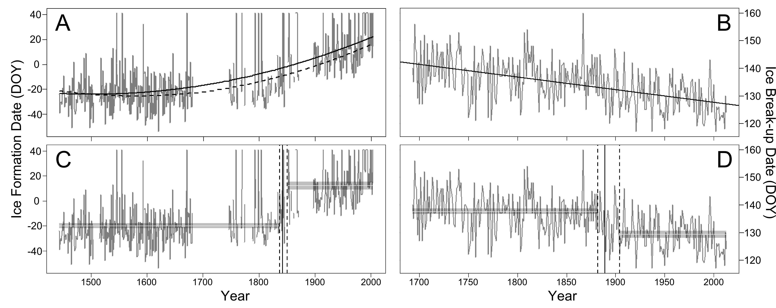
Figure 2. A) Probability of no ice on Lake Suwa by 50-year periods and (B) Difference in probability of no ice for early (1443-1841) and late (1842-2004) years.

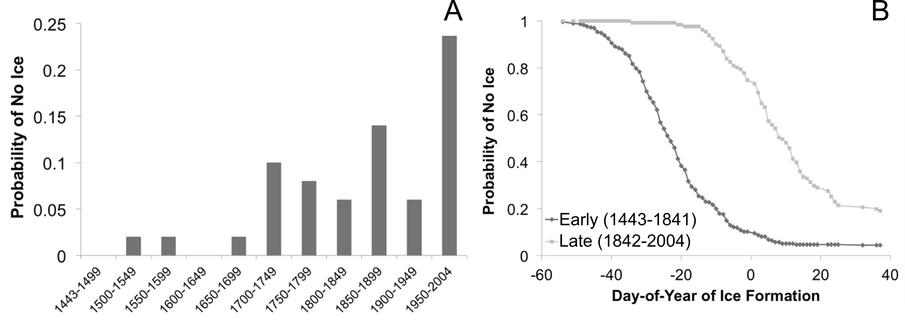
Figure 3. Wavelet power spectrum from continuous wavelet transform analsysis using the morlet wavelet on River Tornio ice breakup dates. (A) Wavelet power spectrum with variance plotted by date (1694-2013) and periodicity of the cycle. Warmer colours symbolize higher variance. The dashed white line is the cone of influence, where boundary effects may be present. The black lines denote variance that is significant from white noise. (B) Average variance at each cycle length for periods before and after the breakpoint. Guassian white noise monte carlo simulation (mean and 95th percentile are plotted as black solid and dashed black lines, respectively). (C) The average variance across all cycles through time. 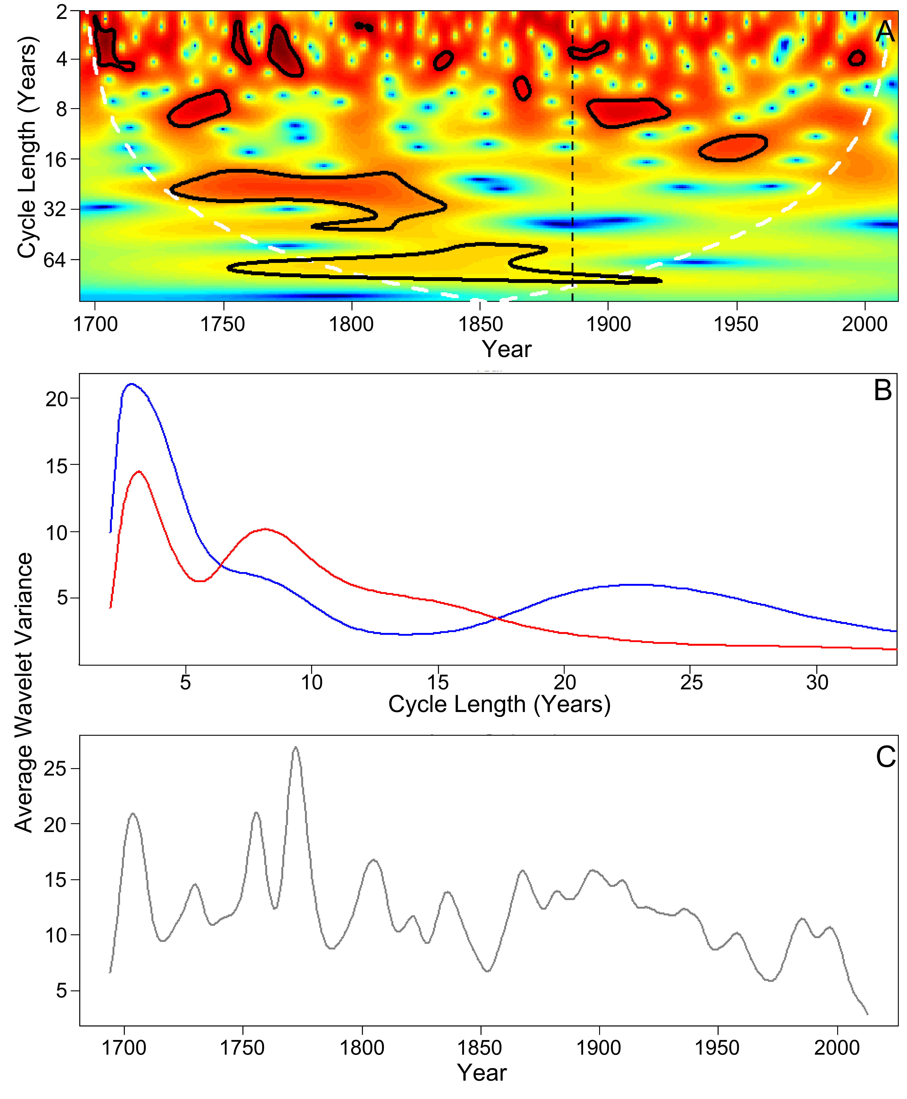

Figure 4. The relative influence of drivers from boosted regression tree models of ice freeze at Lake Suwa and ice breakup at River Tornio. The size of the circle indicates the importance of each variable.

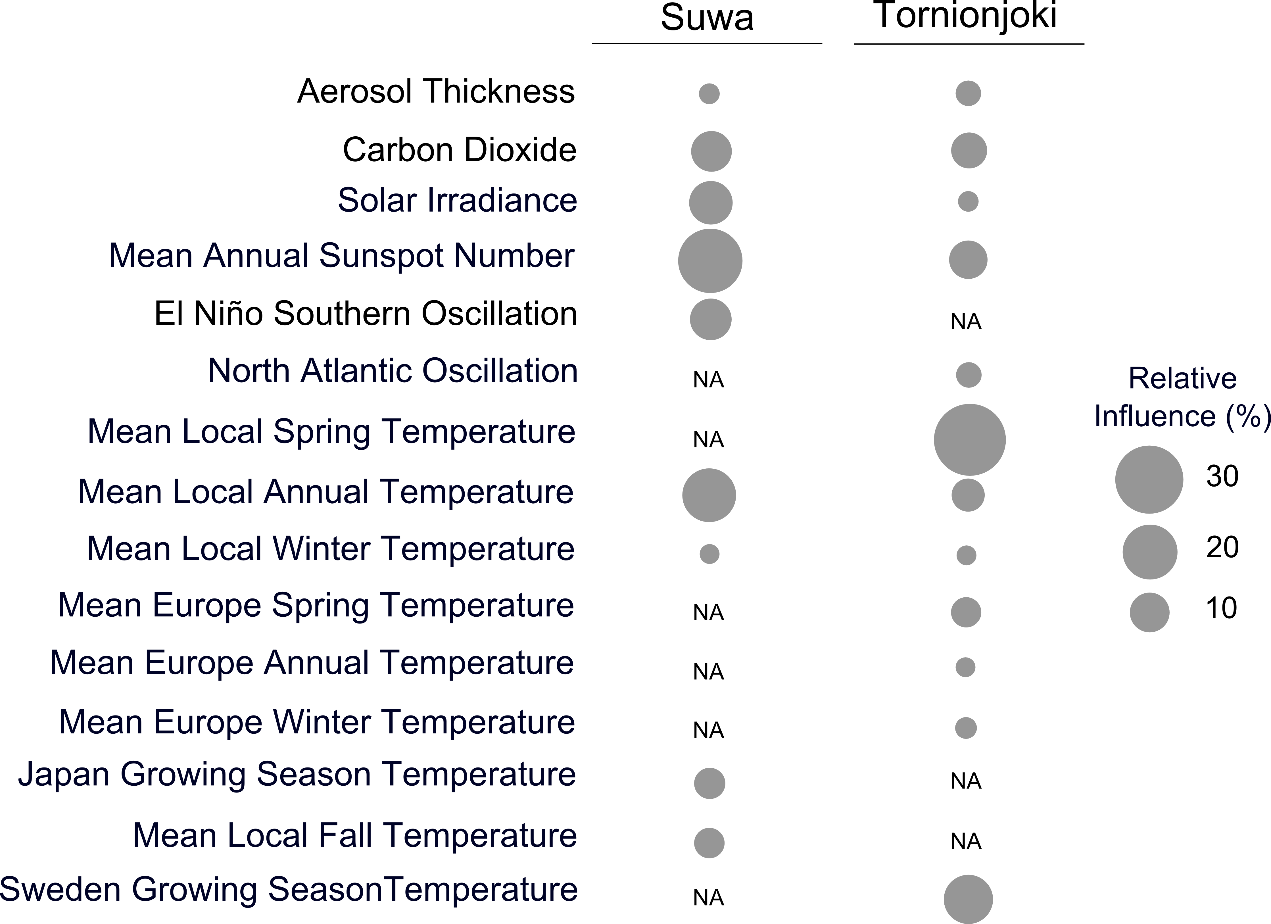

Table S1. Spatial scale, period available, resolution and unit of measure of large-scale climate drivers and weather data acquired.

Dataset | Spatial Scale | System | Period | Resolution | Unit
Sunspot Number | Global | Both | 1700-2012 | Annual | Number
Volcanic Aerosols | Global | Both | 800-2000 | Annual | Aerosol Optical Depth
Solar Irradiance | Global | Both | 9400 BC - 1988 AD | 22-year Averages | W/m²
Atmospheric CO₂ | Global | Both | 1-2012 AD | Annual | ppm
NAO | Regional | Tornio | 1659-2013 | Annual (Winter) | Index
ENSO | Regional | Suwa | 1301-2005 | Annual | Index
Air Temperature | Local (Tornio) | Tornio | 1803-2013 | Annual (Winter, Spring) | °C
Air Temperature | Central Sweden | Tornio | 1107-2007 | Annual (Spring, Summer) | °C
Air Temperature | Central Europe | Tornio | 1500-2007 | Annual | °C
Air Temperature | Local (Tokyo) | Suwa | 1879-2013 | Annual (Fall, Winter) | °C
Air Temperature | Hokkaido, Japan | Suwa | 1557-1997 | Annual (Spring, Summer) | °C

NB: NAO – North Atlantic Oscillation; ENSO – El Nino Southern Oscillation

Table S2. Relative importance of drivers of ice freeze in Lake Suwa and ice breakup in River Tornio based on boosted regression tree models.

Drivers | Suwa | Tornio
Atmospheric CO₂ | 10.6 | 8.1
Solar irradiance | 13.4 | 2.9
Volcanic aerosols | 3 | 4.4
Sunspot numbers | 28.1 | 9.3
ENSO | 11 | -
NAO | - | 4.9
Local annual air temperature | 18.8 | 6.9
Local fall air temperature | 6.1 | -
Winter air temperature | 2.6 | 2.3
Spring air temperature | - | 33.5
Annual Europe air temperature | - | 3.3
Winter Europe air temperature | - | 4
Spring Europe air temperature | - | 6
Japan growing season temperature | 6.4 | -
Sweden growing season temperature | - | 14.5

NB: ENSO – El Nino Southern Oscillation; NAO – North Atlantic Oscillation; CO2 – atmospheric carbon dioxide concentration; AOD – Aerosol Optical Depth; Temp – air temperature

